***Software Testing Assignment***

**Module-1 (Fundamental)**

Q1 What is SDLC

- Software development life cycle

- SDLC is structure imposed on the development of software product that defines the process for planning, implementation and support, and there are number of Different development model

- Software development life cycle is series step or phases that provide for development

-there some phases in below

Requirement

analysis

design

development/implementation/code

testing

maintenance

Q2 What is software testing

--> software testing is part of to used identify the correctness, completeness, and quality of development computer software

--> software testing is part of software development process

-->software testing activity to defect and identify the defect in software

--> to release quality product to the client

Q3 write the SDLC phases with basic introduction

* SDLC phases

requirement

analysis

design

development/implementation/code

testing

maintenance

(1) requirement

- establish customer need

- usage scenarios

- features

- requirement will change!

- plan for change

- function requirement

- non-function requirement

- early prototyping [e.g.,]can clarify the requirement

(2) Analysis

-model and specify the requirement -" what"

-this document states in clear what is built

-represent what phases

-the deliverable design document is the architecture

- details on programming language and environment, machines, packages, memory size, platform, interface, data structures, global many other are establish

(3) Design phase

-design Architecture document

-implementation plan

-critical priority analysis

-performance analysis

-test plan

- the architecture team also typical scenarios a test plan

(4) implementation phase

-implementation =code

-critical error removal

(5) testing phases

- simply quality is very important

- customer satisfied with quality of product will remain loyal and wait for the new functionality in the next version

- unit testing

-stress testing

- application testing

- internal testing

- regression testing

-testing phase is performed by a different team after the implementation is completed

(6) Maintenance phase

-updating all analysis , design and user documentation

- corrective maintenance: identifying and repairing defects

- adaptive maintenance: adapting the existing solution to the new platforms

- perfective maintenance: implementing the new requirement in spiral lifecycle, everything after delivery and deployment can be considered “maintenance”

Q.4 Explain phases of the Waterfall model

* Waterfall model (classical software life cycle)
* the classical software life cycle is a the software development as a step-by-step “waterfall” between the various development phases
* this flow like water

requirement

analysis

design

implementation

testing

maintenance

* requirement must be frozen to early in the life cycle
* requirement are validated too late
* Applications (when to use)
* product definition is stable
* requirement is very well and documented, clear and fixed
* the project is short
* technology is understood and not dynamic
* Advantages of waterfall model
* quality of the product is good
* since requirement changes are not allowed so finding bugs will less
* process and results are well documented
* phases are processed and completed one at the time
* clearly defined stages
* easy to arrange tasks
* Disadvantages of waterfall model
* high amounts of risk uncertainty
* not good model for complex and objects-oriented project
* requirement changes are not allowed
* total investment is more because time to take for rework on defect is time consuming to high investment
* testing start only after the coding
* it is difficult progress within stages

Q.5 write phases of Spiral model

1. Planning = determination of objectives, alternatives and constraints
2. Risk analysis = analysis of alternatives/resolution pf risk
3. Engineering = development of the “next level” product
4. Customer evaluation = assessment of the results of engineering

* Application
* For medium to high risk project
* Significant change are expected in the product during development cycle
* When costs and there are a budget constraint and risk evaluation is important
* Released in multiple version
* Advantages of spiral model
* Testing in done in every cycle before going to next cycle
* Changing requirement can be accommodated
* Allow for the extensive use to prototypes
* Users see the system early
* Disadvantages of spiral model
* Management is more complex
* Spiral may go indefinitely
* Process is complex
* Rechanges are not allowed in between in cycle
* End of project may not be known early

Q.6 What is Agile methodology

- Agile SDLC model is combination of iterative and incremental process model

-rapid delivery software product

- these builds are provided in iteration

- each iteration take time to 1 to 4 weeks

- it divides the software into small increment builds this build are provided in iteration that means big project divides in small project

- each iteration involves all team member working on areas like planning, analysis, design, coding all working

- after the release we check the feedback of deployed software

- if any enhancement needed in the project then it’s done and it’s re-released

Q 7 Explain working methodology of agile model and also write the pros and cons

- Agile SDLC model is combination of iterative and incremental process model

-rapid delivery software product

- these builds are provided in iteration

- each iteration take time to 1 to 4 weeks

- it divides the software into small increment builds this build are provided in iteration that means big project divides in small project

- each iteration involves all team member working on areas like planning, analysis, design, coding all working

- after the release we check the feedback of deployed software

- if any enhancement needed in the project then it’s done and it’s re-released

> Advantage of agile model

* Frequent delivery
* Face to face to communication with the customer
* Less time
* Adaptability
* Promotes teamwork and cross training
* Suitable for fixed and changing requirement
* Resource requirement are minimum
* Easy to manage
* Gives flexibility to developer
* Disadvantages of agile model
* Less documentation
* Maintenance problems
* Not suitable for complex dependencies
* Transfer of technology to new member may be quite challenging due to lack of documents

Q 8 What is SRS

* Software requirement specification
* SRS complete description of the behavior of the system to be developed
* Use case also known as functional requirement the SRS also contain non functional
* Non functional known as ( performance , quality , or design etc. )
* In includes a set of use case that describe all the interactions that the users will have with software
* This standard describes possible structures and quality of a software requirement specification

Q.9 What is oops

* Object oriented programming
* Programming is like writing
* If you can write demonstration you can make a program
* So, programming is also easy
* Object oriented programming is way of writing the programs in organized way object are like a black box where data are hidden
* Learning and practice is necessary

Q.10 Write the basic concepts of oops

* 1) class
* 2) object
* 3) inheritance
* 4) polymorphism

1. Over ridding
2. Over loading

* 5) Encapsulation
* 6) Abstraction
* This all is basic concepts of oops

Q.11 What is class

* Class is collection of data member and member function
* Blueprint for an object
* Ex= class is making all function and data

Q.12 What is object

* Object give permission to access functionality of class

Q.13 What is Inheritance

* Making class from an existing class. Deriving the attribute of some other class
* Inheritance means that one class inheritance the characteristics of other class. this is also called a “is a relationship”
* Ex grandparent

|

Parent

|

Child

Q.14 What is encapsulation

* The process of wrapping the data in a single unit to secure the data from outside world
* In simple word data hiding from other and make it private

Q.15 What is polymorphism

* One name multiple form

1. Over riding = same name of function with parameter but definition will be different
2. Over loading

* Function over loading =same name different parameter
* Constructor over loading = same constructor name but different parameter
* Operator over loading = using the operator to add objects instead variable operands

Q16 draw usecase on online book shopping

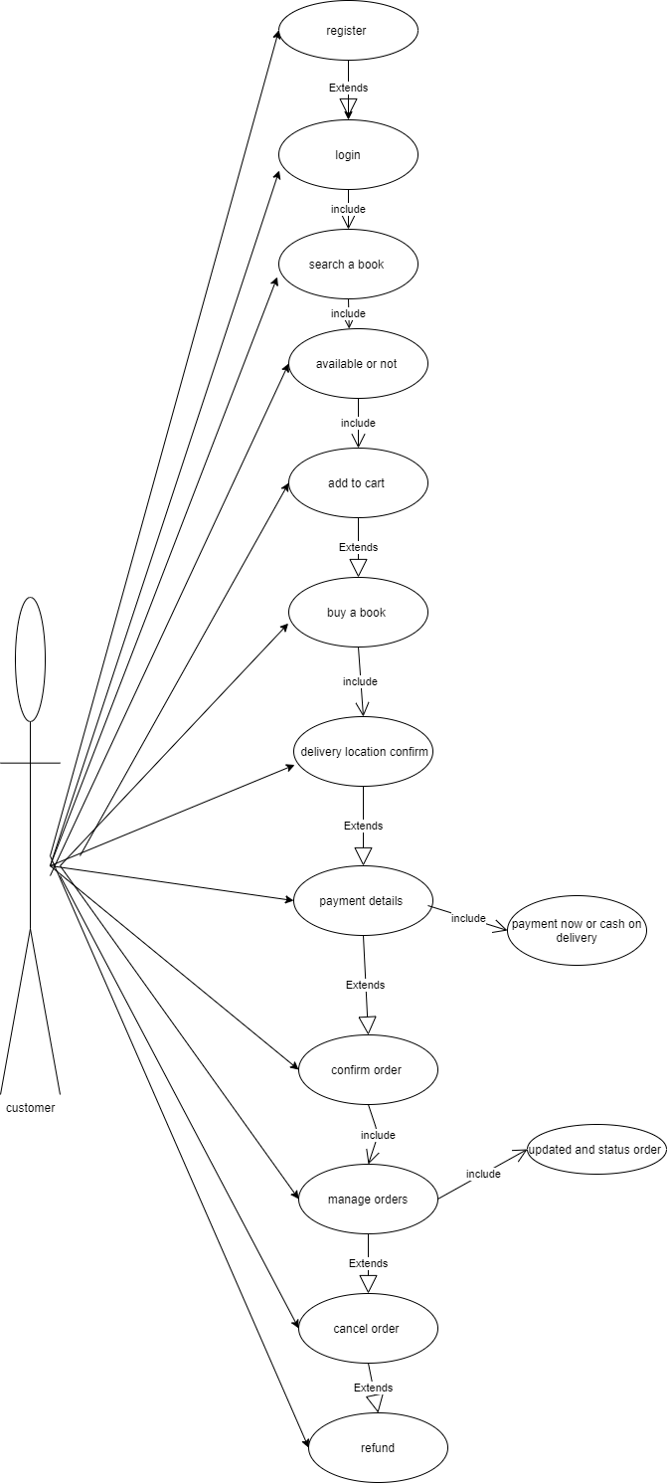

Q17 draw use case on online bill payment system (Paytm)

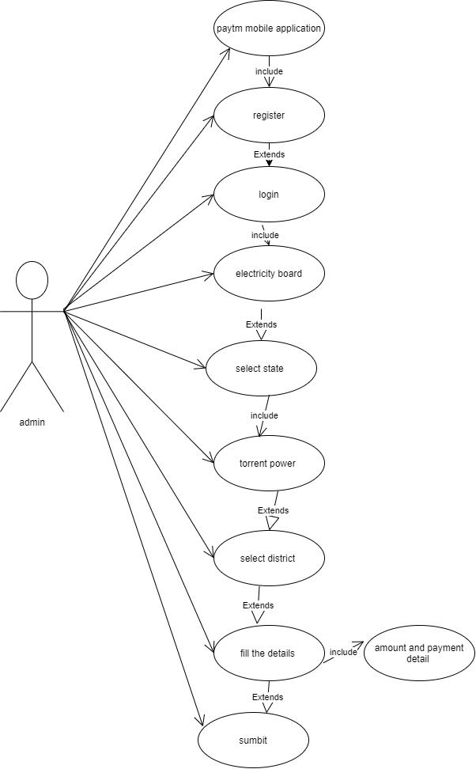

Q18 draw use case on online shopping product using COD

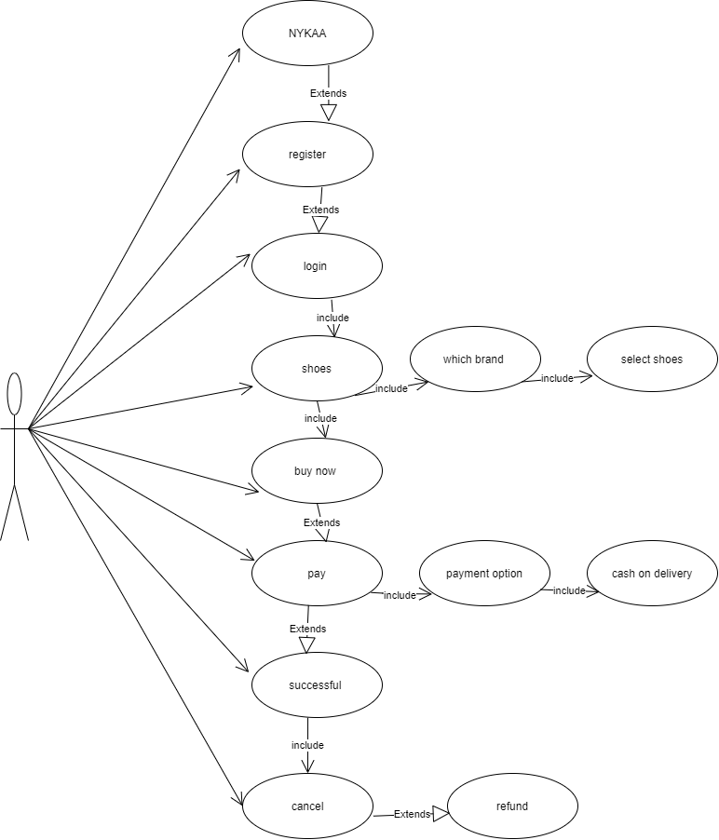

Q19 Draw use case on online shopping product using payment gateway

